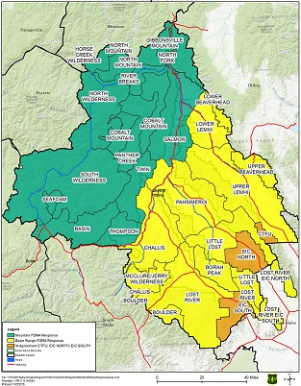

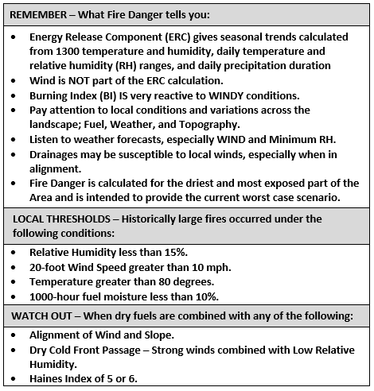

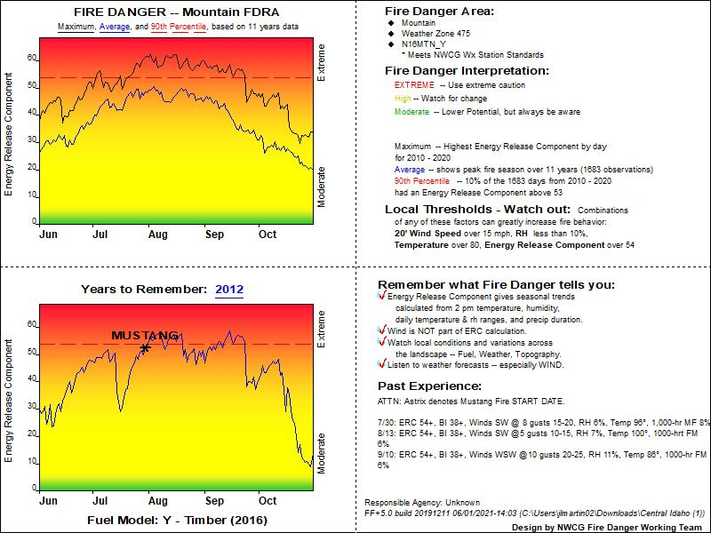

Created on 6/1/2021 by Central Idaho Dispatch

**on 6/1/2020 by Central Idaho Fire Center**